PORTFOLIO: SKILLS AUDIT AND PROFESSIONAL

Table of Contents

Introduction 3
Component 1 – Skills Audit & Reflection 3
1.1 Skills Audit Table 3
1.2 Reflection on Strengths 4
1.3 Reflection for Improvement on weak aspects 5
1.4 Link to Academic and Career Goals 6
1.5 Action Plan 6
Component 2 – Professional Communication 7
2.1 Cover Letter 7
2.2 Invitation design 7
Conclusion 7
References 8
Appendix 10

Introduction
This skills audit and professional communication portfolio comprises two components: firstly, skill audit and reflection, and secondly, professional communication. Component 1 includes a skill audit table where the academic, communication, and personal development skills are rated on a scale of 1 to 5. Based on the rating, there will be a reflection on the strengths and the areas for improvement for the three chosen skills. Next, there will be a short section explaining how the chosen strengths and areas for improvement connect academically and professionally, followed by an action plan considering clear goals for improving 3 chosen skills. Component 2 would include a cover letter for a job role of the particular choice, matching the skills and experience to the job description, and then an attractive invitation for a student social event.

Component 1 – Skills Audit & Reflection

1.1 Skills Audit Table

Academic Skills
Skill | Rating ( 1-5 )
Research skills | 5
Critical thinking | 4
Time management | 4
Writing skills (essays, reports) | 3
Referencing | 4
Problem-solving | 2
Digital Literacy ( basic computer skills) | 4
Communication Skills
Skill | Rating ( 1-5)
Verbal communication | 2
Listening skills | 4
Email and formal writing | 3
Group discussion and teamwork | 5
Personal Development Skills
Skill | Rating ( 1- 5 )
Self-confidence | 3
Adaptability | 4
Stress management | 4
Organisation and planning | 4

1.2 Reflection on Strengths
Strength 1
Research Skills
The research skills have been utilised by me in the personal work as well as group work where I use the skill in order to identify my needs related to academics and personal information as well. The research skill has been helpful in terms of fulfilling my quench for understanding different terms as well as information related to my academics. Any kind of information that has been lacking insights in academics and was not clear to me was understood by me through researching online libraries. I researched in-depth for better understanding of the different concepts and finding current information on the academics. This particular skill was helpful in my group activity in the recent times where I did my research to understand the role of human resource in the current business scenario. In future, the research skill is going to help me in staying updated on any information through the resources or even identify my needs to improve professionally (Bapanova et al., 2023).

Strength 2
Group Discussion and Team Work
Team work and group discussion is one of the communication skills that has been my strength as well. In the accomplishment of any work this has helped me in operating within the team while delivering goals that are intact. I used this skill through my ability to communicate with the team members while carrying out group work. This has been possible with effective communication skills that is an attribute within me. The skill of group discussion was used while doing the activities in group. Team work is crucial for executing all the operations or activities for which the team is being created. I helped in making the communication smoother. In future, this skill is going to help me operate in a team within the organisation. The group discussion or communicating with people will help me with any professional role in management that may be human resource management, business management, or any other professional sphere (Prada et al., 2022).
Strength 3
Organisation and Planning
Organisation skill and planning skill have been used by me in my personal as well group work. On a personal level, I used planning skills for carrying out my studies and for any work that required a schedule like studies or any extra-curriculum activity. I am very organised and use this skill while doing my studies, organising my routine and doing activities on a prior basis. It has helped me not to get stressed during my exams as I am well planned and organised with my studies. In doing group activities as well this particular skill has helped others where the other participants started following me and they thanked me as well. In future, this skill will help me to have a clear view of what is next needed to be done, giving insights clear to accomplish daily operations or achieve any long-term goal (Arvidsson et al., 2023).

1.3 Reflection for Improvement on weak aspects
Skills 1: Problem-Solving
I struggle with problem solving skills during any conflict of interest in any work or discussion. I particularly struggle when I am asked to choose something like topics, academics, or for debate or discussion on any project. Overthinking is the direct impact that hinders me from taking decisions. Taking the decisions for solving the problem during a project work was when I realised this issue within me. This eventually impacts my work and I get stressed in making the final decision. I often get stuck in planning and overthinking that leads to ineffective solutions as well. This has impacted my cognitive processing as I end up thinking rather than taking actions. For the next opportunity, I am going to be prepared beforehand to improve these skills. For this, I will find out approaches and simple methods that are going to help me think logically and take actions accordingly while anticipating the outcome (Anggraeni et al. 2023).
Skills 2: Verbal Communication
I am very shy in expressing my feelings or my needs even if it is any professional career or academics related matter. At times I feel the lack of speech and could not open up to communicate simple requirements through verbal ways. With digital devices and tools I feel more comfortable where I am not visible but can communicate. This happens in the initial stage of conversation as once in a group activity given to us for a week . Once I have overcome this fear of speaking I am more manageable and can communicate effectively as if no such problem existed. This impacts my confidence and makes me more self-conscious that again gives me a sense of absence of speech. I feel like people may end up misunderstanding me or maybe I will not be able to give clarity of my message or intention. I am going to open up more and make small conversations initially while carrying out verbal communication (Mahdi, 2022). I am going to learn communication skills as well.
Skills 3: Self-Confidence
I struggle with self-confidence while doing public speaking where there may be only one person or in a group. Once, while speaking with a classmate over academic work, I was telling the right thing but lacked the confidence to convince. It was revealed after both of us rechecked it. A sense of self-doubt even if it was right worked within me. I lack self-confidence in putting my words to someone so people on the other side like my peers or tutors also doubt whether I am capable of that particular thing or not. This has a negative impact on my personality and character that is going to be a drawback on my side in both personal and professional level. In future also this is going to impact me in terms of getting jobs or in career growth (Gottlieb et al., 2022). Thus, I am going to work building self-confidence by taking up self-grooming classes or tips and tricks that are freely available online to improve in future. In future, I will be more self-conscious in making gestures like eye-contact making me self-confident.

1.4 Link to Academic and Career Goals
Research Skills allow me to conduct research and analyse case studies, theories, and real-life examples, which is essential to support arguments with evidence. The skills have strengthened my ability to gather reliable information and interpret data, thinking in a critical context. For the future career of an HR manager, the research skills would prove beneficial to understand the employee legislations and analyse workforce data. It would also allow us to make informed decisions which are given by data. The research skills would also enable me to stay updated on the best employee and organization HR policies and practices to meet the standards.
Group Discussion and Team Work play a significant role in my academic career, as group presentations and projects enhanced my communication and collaboration skills. These skills would enable me in my future career as an HR manager, where teamwork is essential to collaborate with the senior leaders, employees, and line managers across different departments. Teacher professional team-oriented mindset and focus on helping others so that an organisation and its employees succeed (Herzing University2022). Such academic experience helped me to respect diverse viewpoints of the employers and employees in my future professional life and manage or resolve conflicts, building adverse and positive workplaces.
The strength of Organisation and Planning helps me to manage academic responsibilities effectively and efficiently, meeting the strict deadlines and group projects. Personally, I structured the planning methods and prioritized the important work and social life, maintaining a balance. Teacher professionals must be organised as they juggle multiple responsibilities (Herzing University, 2022). This skill would support me in the role of an HR manager in the future to devise training schedules and employee records, complying with the recruitment process. Strong organizational skills are beneficial for streamlined HR operations in any sector.

1.5 Action Plan
To improve my Problem-solving skills
- For improving my problem-solving skills, I would actively engage in activities that challenge my analytical thinking and ability for decision-making. I will do this by practicing to solve real-life case studies, which are associated with business management and HR. My task will be identifying the problems and finding innovative solutions that justify my decisions, backed by evidence and theories.
- This will be done by me weekly throughout my academic tenure and while participating in work-based learning opportunities.
- To support these goals, I would take the help of sources like academic journals, online learning platforms like LinkedIn learning, and take constructive feedback from the tutor and my classmates. LinkedIn learning is a learning platform for enriching reflective thinking and lifelong learning (MacKenzie, 2023). As a source, I would also engage myself in group discussions, which would allow me to analyse different perspectives, solidifying my ability to resolve complex scenarios.
To improve my verbal communication
- For improving my verbal communication, I would participate dynamically in the group seminars, discussion and tutorials. I need to expand my vocabulary and pay attention to my body language and tone, practicing active listening and thinking before speaking. I will participate in public to build my confidence. I would use direct language, avoid jargon, and maintain eye contact and gestures showing engagement. For example, I will reward the important points before any group discussion to improve my speaking.
- This will be done by me every month through the group discussion and lectures
- Regarding the support sources, I would participate in and enrol myself in presentation skills workshops and university support services, and record my presentations to understand my flaws and correct them in the future. I will also take the help of online tools like TED talks for observing speakers and their different techniques. Tools like Ted Talks act as learning tool for refining English speaking skills (Tran and Nguyen, 2024). To expand my vocabulary, I will read journals and storybooks to learn new words for expressing myself better.
To gain self-confidence while speaking publicly.
- For gaining self-confidence while speaking in public, I would memorize the material to be spoken and practice speaking. I would maintain direct eye contact with the audience. I will also volunteer myself for small speaking roles in group presentations, which will allow me to speak independently in public without any anxiety and stress.
- To achieve the goal, I would practice public speaking in weekly and monthly basis, which will increase my confidence level over time
- Considering the support resources, I would enrol myself in public speaking workshops and take advantage of the university's support services, along with online platform resources.

Component 2 – Professional Communication

2.1 Cover Letter

XYZ

+442071234567

xyz@email.com

10th February, 2026

Hiring Manager

Thesleff Group

Los Mochis, London City

Subject: Application for the post of HR manager, Thesleff Group

Respected Sir/Madam

I have come across the job role of an HR manager in your organisation through the online job portal and express my strong interest in the position at Thesleff Group. I would like to draw your attention to my skills and abilities Making myself the best person for the particular job role. I have a people-centric approach with thorough knowledge of HR based on my previous job experience working in a dynamic and competitive landscape. I am excited to contribute towards the growth and success of your hospitality portfolio operating in Los Mochis, London City, Sale e Pepe Knightsbridge, and Viajante87. I am a proactive and forward-thinking HR professional who has the capability to operate independently and communicate with confidence and influence at all levels as the job description requires.

As stated, I have worked in a team-oriented environment previously, and I value group discussion and teamwork, which are the essential drivers of organisational success. You would be overwhelmed to see my creative and innovative thinking approach with ownership across the fast-growing hospitality company. I can communicate clearly and confidently with the Frontline employees, managers, and other external members. I have a clear understanding of the HR policy and procedures specially in the hospitality sector. As the job role requires the manager to oversee the full employee life cycle, including HR Administration and employment, along with payroll support. I have excellent organizational and database decision-making abilities. My basic computer skills and digital literacy help HR run smoothly by keeping track of employee records and internal communications. In order to maintain accurate documentation and expedite procedures for data-driven reporting, I feel very at ease utilizing digital platforms. I want to call your attention to my main asset, which is my ability to adapt. Being employed in a fast-paced, high-pressure setting, particularly in the hospitality industry, has improved my capacity to react coolly and collectedly to situations involving new hires, organizational expansion, and employee-related problems. I can also manage stress, which allows me to remain professional and emotionally intelligent even in trying circumstances. This skill would allow me to handle employee relations with discretion and transparency, protecting the interests of both the employees and the business.

I have proven HR experience as a manager with more than 2 years of experience within the hospitality sector, and have a strong knowledge of UK employment laws. Effective time management and organisational skills are central to my style of working. I am competent to manage tight deadlines and handle employee matters urgently. I will be capable and confident to manage HR administration and payroll coordination, adhering to the UK laws and legislation. Especially in the hospitality sector, each manager must have Research and critical thinking skills, which I possess due to previous work experience working in a multinational organization within the hospitality sector. As I have utilised HR metrics and employee feedback along with policy reviews for recommending improvements regarding engagement and retention, I would similarly use them for the particular job role and would deliver greater results. The personal analytical approach would enable me to act as a trusted advisor to management, balancing the priorities of the organisation while caring for the well-being of the employees, which is necessary for all the stakeholders of the sector.

I am enthusiastic about the opportunity to bring my unique skills to the HR manager position at Thesleff Group. I am confident that my background in developing effective HR strategies will be an excellent match for your team. I possess strong interpersonal and communication skills, and my proficiency in HR software, coupled with my ability to analyse and leverage employee data, supports the strategic decision-making process. In my previous job role, I utilized strong planning and coordination skills, which are essential for overseeing HR processes across multiple sites specially the two new openings in 2026 at Sale e Pepe Mare at The Langham Hotel & Ma/Na Mayfair. My approach is future thinking and solution-focused, aligning closely with the Thesleff Group, which emphasizes creativity, innovation, growth, and operational excellence.

I am deeply impressed with Thesleff Groups' initiative and commitment to diversity and inclusion within the workplace and they are accepting qualified individuals from diverse backgrounds. Thank you for considering my application. I am eager to bring my talents and skills to support the goals and vision of the organization. I am eager to discuss this exciting opportunity with you. Always feel free to contact me at the number provided above or through email for scheduling any interview

Yours Sincerely

ABC

2.2 Invitation design

You are invited to an exciting music fest, which is the ultimate student night out.

This music event is designed to help you relax and have fun outside the classroom. Whether you are a new student or pass out, this event is a perfect opportunity for meeting and greeting new people, making new friends, and enjoying a bubbly social atmosphere.

Join us on the 15th of February 2026 at the Student Concert Hall, in the evening, around 5:30 p.m. The evening will be filled with music, interactive games, and activities. There will be refreshments and food to support your energy. Besides music, there will be fun-filled activities and games so that everyone feels welcome and encourages teamwork and laughter. There will be plenty of space to unwind and enjoy yourself.

This event is open to all students, so bring your friends to the venue and create lasting memories and experiences. This music and fun night are organised to take a break from the academic routines and stranded in the student community.

Location: The Main Student Hall, William College, London

Date: 15 th February, Sunday, 2026

Time: 5.30 pm to 11.30 pm

RSVP: Please confirm your attendance by the 10th of February by signing the form at the student services office.

We are looking forward to seeing you at the event, and come with lots of positive energy and get ready for a fun field evening

Conclusion

The overall assignment allowed me to reflect on the particular strengths and skills posed personally, along with the areas for improvement, and through the clear action plan personally, I would be able to improve the skills in my future professional career. Writing the cover letter aligning with the respective job role helped me personally to reflect on my strengths and how they would allow me to match the job positions and responsibilities in the sector.

References
Anggraeni, D.M., Prahani, B.K., Suprapto, N., Shofiyah, N. and Jatmiko, B., 2023. Systematic review of problem based learning research in fostering critical thinking skills. Thinking Skills and Creativity, 49, p.101334. https://doi.org/10.1016/j.tsc.2023.101334
Arvidsson, P., Janeslätt, G., Wennberg, B., Lidström-Holmqvist, K., Holmefur, M. and Hayat Roshanay, A., 2023. Evaluation of the group intervention “Let’s Get Organized” for improving time management, organisational, and planning skills in people with mild intellectual disability. Scandinavian Journal of Occupational Therapy, 30(8), pp.1257-1266. https://doi.org/10.1080/11038128.2023.2217545
Bapanova, G.K., Orekhova, N.V., Kadirsizova, S.B., Kasbayeva, G.S. and Sholpankulova, G.K., 2025. Research skills as the student learning achievement. International Journal of Educational Reform, 34(3), pp.543-558. https://doi.org/10.1177/10567879231155874
Gottlieb, M., Chan, T.M., Zaver, F. and Ellaway, R., 2022. Confidence‐competence alignment and the role of self‐confidence in medical education: A conceptual review. Medical Education, 56(1), pp.37-47. https://doi.org/10.1111/medu.14592
Herzing University. (2022). 7 Skills for Human Resource Professionals. [online] Available at: https://www.herzing.edu/skills/human-resources. [Accessed 10 Feb. 2026].
Indeed.com. (2026). HR Manager - London W1K - Indeed.com. [online] Available at: https://uk.indeed.com/viewjob?jk=fd87febb3fb6df3e&from=searchOnDesktopSerp%2Cwhatautocomplete%2CwhatautocompleteSourceStandard&tk=1jh3u17hghn21862 [Accessed 10 Feb. 2026].
MacKenzie, A., 2023. Nudging lifelong learning and reflective thinking in engineering students utilizing LinkedIn learning. International Journal of Advanced Corporate Learning, 16(2), p.57.https://doi.org/10.3991/ijac.v16i2.35555.
Mahdi, D.A., 2022. Improving speaking and presentation skills through interactive multimedia environment for non-native speakers of English. Sage Open, 12(1), p.21582440221079811. https://doi.org/10.1177/21582440221079811
Prada, E.D., Mareque, M. and Pino-Juste, M., 2022. Teamwork skills in higher education: is university training contributing to their mastery?. Psicologia: Reflexao e critica, 35, p.5. https://doi.org/10.1186/s41155-022-00207-1
Tran, N.K.C. and Nguyen, T.T.H., 2024. The use of TED Talks to enhance EFL students’ public speaking skills: English-majored seniors’ practices and perceptions. International Journal of Language Instruction, 3(1), pp.66-90.https://doi.org/10.54855/ijli.24315

‌

Appendix
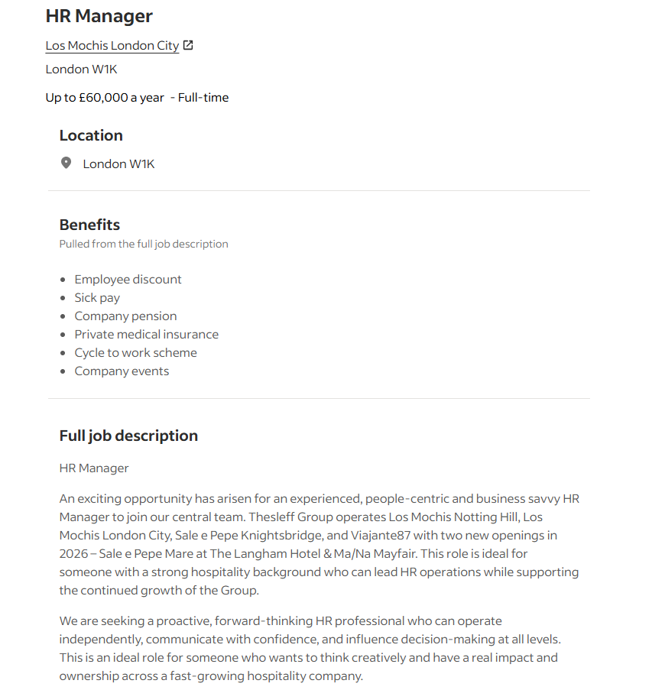
Figure 1: Job advertisement for HR manager
(Source: Indeed, 2026)
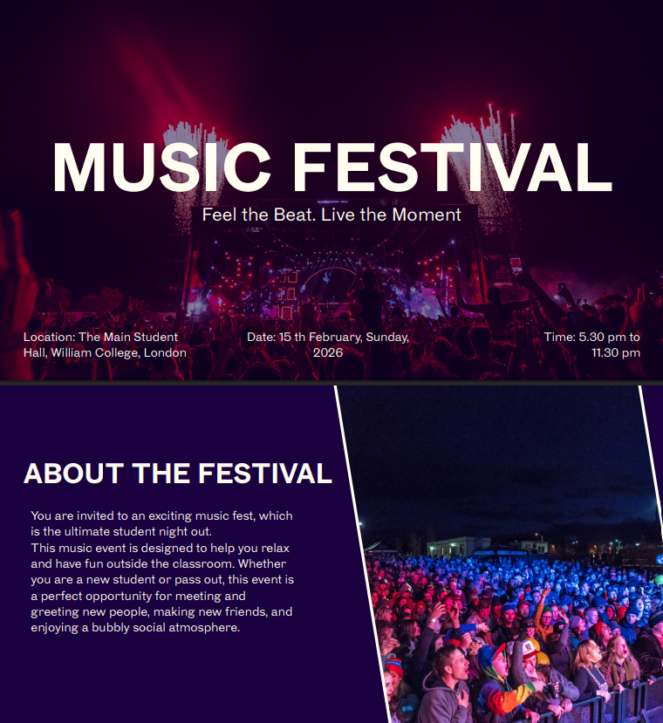
Figure 2: Invitation Card

