INDIVIDUAL PORTFOLIO
Table of Contents

Task 1 – Creating and Sharing 3
Task 2–Poster: “Manage Time for Everyday Success” 13
References 19

Task 1 – Creating and Sharing
a) How to create and share a Folder in file-sharing platforms
The chosen file-sharing platform for creating and sharing a folder is Google Drive. Google Drive is a cloud-based file storage and synchronising service that allows learners and professionals to share files and folders with others (Zamiri and Esmaeili, 2024). It allows setting permissions for controlling who can view, edit, or comment on the files and documents.
Step 1: First, open a web browser like Google Chrome → Go to www.google.com/drive → Sign in using your personal Gmail account.
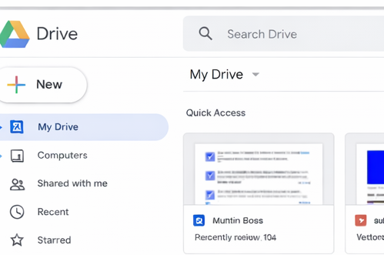
Figure 1: Opening the web browser and Google Drive
Step 2: To create a new folder on the left-hand side of the screen, click “new” Button → From the drop-down menu select folder→ a pop-up window will appear asking for the folder →The name of the folder is typed as “BMAF011 Digital Essentials” → Lastly click on the “Create” menu → The folder with the name will be created.
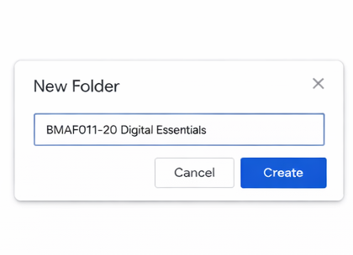
Figure 2: Creating the folder with the name
Step 3: To locate and open the folder, find the folder “BMAF011 Digital Essentials” in the personal Google Drive. →The folder has to be double-clicked to open it→ the folder will contain the files that are added
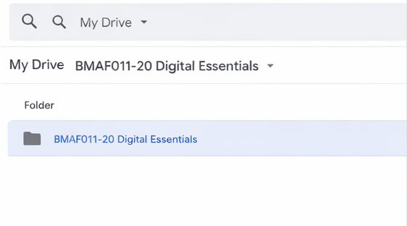
Figure 3: Creation of the folder
Step 4: For sharing the folder, right-click on the folder named “BMAF011 Digital Essentials” → →Select the “Share” from the menu (the icon has a person face with a plus sign) at the top
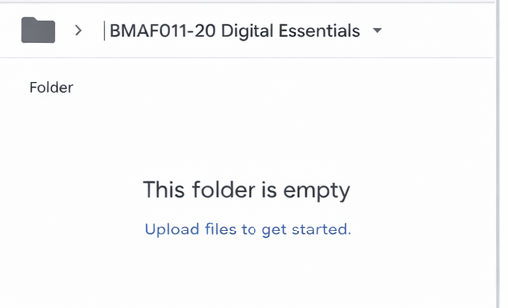
Figure 4: Folder Created
Step 5: For adding people and setting general access, the share window will be opened → from the “add people and group” menu select the email address as a person to be shared → from the permission level choose viewer, commenter, or editor→ To send the file, click “Send”
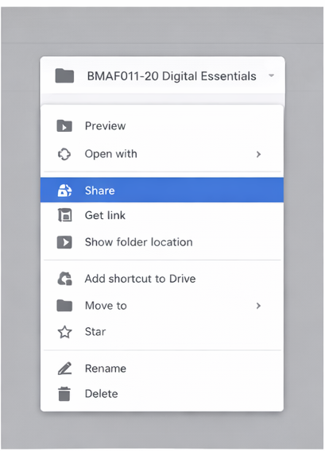
Figure 5: Sharing of the file on Google drive
Step 6: To share using a link within the same share window, locate “General Access” → changing the access from “restricted” to “anyone with the link” based on who wants to view the file → next choose the appropriate role whether viewer or editor → clicking on “Copy Link” → Lastly, click on the “Done” menu.
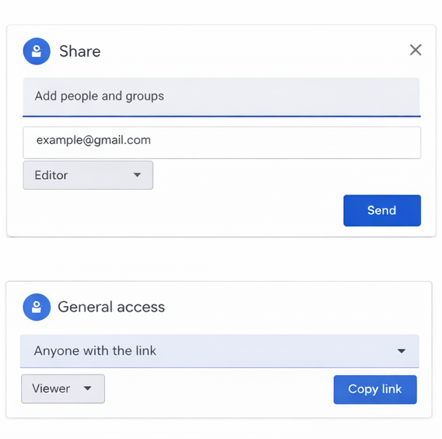
Figure 6: Adding the names of participants and sharing the folder
Step 7: To confirm the sharing process, share the copied link in the document or browser to confirm access → secondly, ensure that the folder opens correctly, displaying the name that has been given to the file.
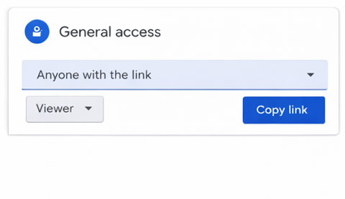
Figure 7: Access to the files in Google Drive
Following the step-by-step guide, one can successfully create and share a Google Drive folder with the desired name. This folder can be utilised for storing and sharing digital files securely for academic and professional purposes. Google Drive offers secure cloud-based storage and synchronization with seamless real-time collaboration and easy file sharing with cross-platform access like desktop, mobile, or web services.
b) How to create and share an online meeting invite in Google Meet
The chosen platform to create and share a meeting invite is “Google Meet”. Google Meet is an application combining video conferencing, online meetings, charts, and mobile collaboration, providing remote conferencing services and providing a potential solution in the learning and professional journey (Marian, 2023).
Step 1: First, open a web browser, namely Google Chrome → Go to www.google.com →Sign in using the personal Gmail account.
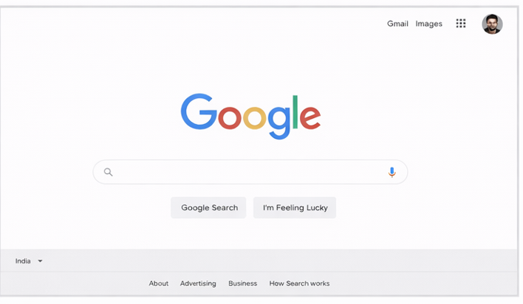
Figure 8: Opening the web browser and typing Google Meet
Step 2: To access Google meet, click on the Google app menu in the top right corner → Now select Google Meet from the list of applications → One can alternatively go to meet.google.com directly.
Step 3: To create a new meeting, first, on the homepage of Google meet click on “New Meeting." → A drop-down menu will appear with options such as creating a meeting for later, starting an instant meeting, and scheduling the meeting in Google calendar →. After deciding, select the "Create a meeting for later” option.
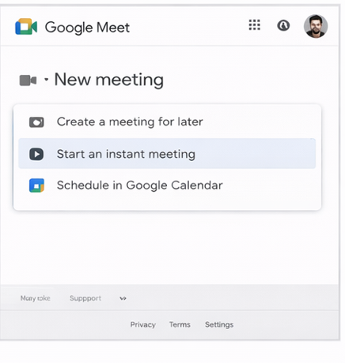
Figure 9: New meeting on the app
Step 4: After selecting " Create Meeting ", a link for the meeting will be generated. → On generation of the link, click “Copy” to copy the link of Google meet → The copied link can be shared via messaging applications, email, and other platforms.
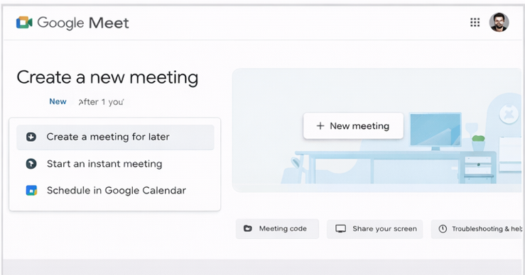
Figure 10: Creating a new meeting in Google Meet
Step 5: For She during the meeting using Google calendar from the “new meeting” options select “Schedule in Google Calendar" → the Google Calendar will open in the new tab → After that enter the details of the meeting like title (topic for discussion), date and time along with the description mentioning the agenda or instructions → The Google meet link is automatically added to the event.
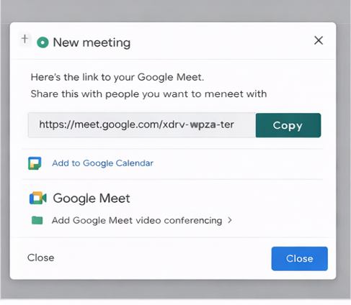
Figure 11: Copying the link of the meeting
Step 6: For adding the guest and sending the invite click on the “Add guests” field and enter the email address of the participants → next review the details and permissions of the meeting → click on the “Save” menu → When the prompt appears, click on the “Send” option to email the meeting invite to the participants of the meeting.
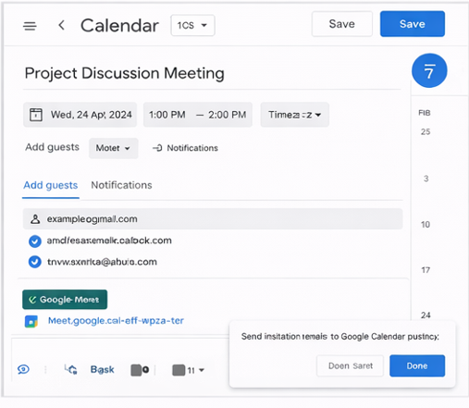
Figure 12: Sharing the link of the meeting with the respective participants
Step 7: The link of the meeting can be shared manually, for which first the calendar event needs to be opened → The link of the Google Meet is copied → The link can be pasted and shared by different platforms like WhatsApp and Microsoft Teams, or via email as required.
Sending invitations through Google Meet, utilising links and phone numbers, helps in easy collaboration during video calls and conferences. The application enhances security as the meetings are encrypted by default, and the host has full control to mute or remove the participants to make the discussions safe and private. The participants can't join the meeting without installing the software using only the mobile application, making it highly accessible.

Task 2–Poster: “Manage Time for Everyday Success”
Defining Time Management
According to Coursera (2024), Time management is the conscious planning and controlling of time spent on specific tasks for increasing efficiency. It involves setting deadlines and writing a to-do list, and familiarising oneself with rewards and phrases to accomplish certain activities. Time management is all about organising personality and doing work to make the best of the available time. Time Management can also be defined as a form of decision-making used by individuals for structuring, adapting, and protecting their time in changing conditions (Aeon et al. 2021). Considering the impact and importance of time management in academic and professional life, it influences job performance, revealing a positive influence, and it has been found that time management has a significant impact on increasing satisfaction in life and, to a greater extent, elevated performance. Summing up, time management can be considered an excellent well-being enhancer and performance booster. Good time management allows for the creation of a well-balanced routine that is effective in reducing stress, which translates to better physical and cognitive health.
Management of time effectively has enabled an increase in productivity and efficiency, and this can be done by emphasizing the tasks of importance along with setting realistic deadlines (Puppis, 2024). By taking these steps, an individual can focus on the urgent task and meet them timely manner.

Most important time management tips
Goal setting
For proper management of time, planning is quite essential along with setting the goals. One needs to first set the priority of the goals of the task, marking them either as long-term, medium-term, or short-term goal, and what needs to be achieved by the task. Setting a priority presents a clear picture of the next task to be done. For proper time management, it is often helpful to write the goals down and keep them somewhere visible so that it provides a reminder of what needs to be done. SMART goals can be utilised for proper management of time, setting them as specific, measurable, attainable, relevant, and time-bound. Using the SMART goal, one can build visibility, and this system ensures that the goals are relevant and quantifiable with specific timelines specified up front (Chen et al. 2021). Taking an example, one needs to learn about digital tools to be competitive in the academic and professional fields. Setting a goal in the mobile application for learning about the digital tool for 1 hour every day and establishing a consistent practice, one can achieve the goal (‌ Martins, 2025). To make the learning of digital tools attainable, I personally need to practice with peers or professionals about the digital tools to make it technically achievable. Without having a proper timeline for the SMART goals, one will continuously procrastinate or Dragon so deadlines provide a sense of urgency to accomplish the short-term goals and switch to long-term ones. According to ‌ Martins (2025), deadlines are essential for the achievement of goals because they motivate an individual to act and stay focused on the work. Without a deadline, ignorance becomes prevalent, and the goals become less achievable.
Avoiding procrastination
Procrastination is essential for managing time effectively, as it leads to stress and missed deadlines, which decline productivity and performance. According to Ahmed et al. (2023), about 64% of the students admitted that they felt stressed due to procrastination and not being able to curb it, leading to poor academic performance. Procrastination leads to a lot of stress and poor time management, along with incomplete work, which leads to guilt and poor academic performance among students in higher education. University and college students realise that management of time is the biggest challenge in their academic career. Procrastination comes into play while involved in group tasks and projects (Psychological & Counseling Services, 2020). For proper time management, one must take control of their behaviour and properly use time. Talking about the steps to challenge procrastination and manage time involves challenging negative thoughts and converting them to positive thoughts. As an example of thoughts like “This is too hard or boring”, “I will do this later as there is a lot of time left,” change them into “I will start with a simple task, and this is not boring or hard but will help me to achieve my goals”. Breaking down work into simple, manageable tasks helps in improving time management. Such as breaking down a complex chapter into 2 to 3 days helps in better learning. Dividing big projects into tiny, manageable sub-tasks reduces academic stress and burnout.
Prioritisation
Prioritising and planning the tasks and to-do lists is a great way to plan the tasks that one needs to do. For planning and privatizing effectively, it is essential to maintain a diary or time sheet of some kind, or using any electronic calculator, such as those found in Google Mail or Outlook, is found to be useful. Calendars can also be used in mobile phones, and in this method, it is important to use deadlines and a time frame. Prioritisation using the ABC system helps to prioritize the tasks that need to be completed based on their importance (Nesamalar et al. 2022). It has been found that highly productive people plan that day out to be accomplished within the day, and through this process, a person fully focuses on completion of the important tasks, avoiding distractions and wasting time. One needs to be disciplined and maintain focus, not getting diverted while completing the tasks from the to-do lists. As an example, time management is a crucial issue for higher education students as they need to juggle not only academic life but also family obligations and personal goals. This is a challenge, creating anxiety and stress. In the higher education level, it has been found that the students demonstrated poor time management skills (Nesamalar et al. 2022). Time management in the University students is crucial for the completion of tasks that require mastery of skills and self-governance (Au et al. 2023). It has been found that students who do not adhere to study time management strategies fail in their academic achievement.
Avoid time stealers
For effective tips to manage time, one must avoid time stealers like email, the internet, mobile phones, and conversations with people. Emails and online messaging are the biggest time stealers for people, as when a person hears the “ping” on their notifications or inbox, it is very inviting to grab attention when someone is doing something difficult or important, and is termed as “Ping fatigue”. It has been found that more than three-quarters, which approximates to 77% of the employed, found notifications from workplace digital tools to be a distraction. According to a survey, most of the employees are distracted every 15 minutes by a digital notification, which leads to about 160 distractions in a week (Smith, 2024). To avoid this, one must set times for checking messages during the day and turning the notifications off in between. Professionals using Slack or Teams can set the “busy” status, which lets everyone know ahead of time to respond more slowly (Robinson, 2025). This removes the temptation to read everything that comes in the message box. The Internet is the most crucial and massive time stealer. As an example, a student or a professional start with internet research, and after 20 to 30 minutes, they start checking Facebook, Instagram, and continue for hours without actually doing the work. To mitigate this, one needs to be disciplined in using the internet as a tool to complete the task. Mobile phones are quite distracting and an obstacle at the present age to accomplishing a task.

Importance of Time Management in Academic Success
Time management plays an important role in academic success as it directly enhances performance and reduces stress, and maintains a balanced lifestyle. Mastering time management is the key to success for learners, and it involves smart allocation of time, which boosts productivity and achievement of goals. But for successful time management skills, an academic learner needs to set priorities and plan tasks using effective time management. According to Cambridge learn (2024), Proper time management allows learners to allocate sufficient time for studying and understanding the academic materials. This ensures a deep understanding of the academic subjects and better retention of the information. The learners must have a balanced schedule so that they can focus on their personal and academic responsibilities and balance their extracurricular activities and socializing, preventing feeling overwhelmed or burnout. Time Management, facilities setting, and achievement of goals from completion of assignments are key to preparing for the exams, and the students can track their progress based on the goals and objectives. For higher education and tertiary students, essential skills that are tie management are powerful predictors for academic performance (Ahmady et al. 2021). It has been found that students who do not plan their time effectively fail to meet the academic deadlines and contribute to poor academic performance.
Time Management significantly impacts study engagement. Propose that self-control encompasses the capacity of an individual to restrain impulses and manage their own conduct for enhancing the attainment of enduring objectives (Fu et al. 2025). The tertiary education phase is the critical period for academic growth, and time management plays an important role for college students. It has been found that self-control and mobile phone dependence act as significant mediators in the nexus between time management and study engagement. The Institutions of higher education must implement strategies that aim to enhance college students' time management skills and self-regulation, reducing dependency on mobile devices and digital tools other than education, which increases engagement and study, and enhances learning and academic outcomes. The students, for effective management of time, can develop strategies that help them to balance academics and personal life. They can prioritise and plan using the Eisenhower Matrix, which follows four quadrants. Prioritizing the tasks by setting SMART goals and following diaries and calendars or mobile clock applications, taking strategic breaks will be able to enhance their academic performance and minimise stress. The development of strong time management skills within academic learners inculcates other associated skills and contributes to the long-term success in both personal and professional career endeavours.

Role of Time Management in Career Development
Time management is an essential driver for the development of a career as it is directly linked to productivity and the achievement of goals. Proper time management enables professionals to prioritise high-impact tasks and projects and improve work quality, which leads to better rewards and promotions. Proper time management allows professionals to complete projects tackling enough time, which boosts their performance and innovative results. It can also be associated with improved decision-making abilities. Allotting enough time for tasks ensures that the decisions are based on merit without missing the deadlines. According to Aeon et al. (2021), considering time management and performance in professional settings, it has a moderate impact on performance at work, and it is related to performance appraisal, motivation, and job involvement. Time Management helps boost performance and enhances well-being. Considering real examples for proper management of time, employees in organisations must prioritize tasks based on their efficiency. The employee must create a to-do list and identify the high-impact tasks that need to be completed first and reference them in case of last-minute pressure. They can use Google Calendar for daily research or learning a new software, which will lead to promotion in a specific role. Utilising tools for managing the workload allows them to meet the deadlines consistently and participate in more challenging projects. According to Blaschka (2021), for maximizing productivity and management of time, professionals must turn off social media notifications and reduce “ping fatigue” on their mobiles and computers, and put their phones on airplane mode. They need to undertake strategies for removing distractions and helping them focus on the work. Multitasking has been found to destroy clarity, which is essential for productivity and management of time. Professionals must practice minor asking and focus on a particular work, considering that it is important, which will help them to meet the deadlines and provide good outputs.

References
Aeon, B., Faber, A. and Panaccio, A., 2021. Does time management work? A meta-analysis. PloS one, 16(1), p.e0245066.https://journals.plos.org/plosone/article?id=10.1371/journal.pone.0245066
Ahmady, S., Khajeali, N., Kalantarion, M., Sharifi, F. and Yaseri, M., 2021. Relation between stress, time management, and academic achievement in preclinical medical education: A systematic review and meta-analysis. Journal of education and health promotion, 10, p.32.https://pmc.ncbi.nlm.nih.gov/articles/PMC7933620/
Ahmed, I., Bernhardt, G.V. and Shivappa, P., 2023. Prevalence of academic procrastination and its negative impact on students. Biomedical and Biotechnology Research Journal (BBRJ), 7(3), pp.363-370.https://journals.lww.com/bbrj/fulltext/2023/07030/prevalence_of_academic_procrastination_and_its.7.aspx#:~:text=Consequences%20of%20procrastination,-Consequences%20of%20procrastination&text=65%25%20of%20the%20participants%20admitted,guilt%20and%20poor%20academic%20performance.
Au, A., Caltabiano, N.J. and Vaksman, O., 2023. The impact of sense of belonging, resilience, time management skills and academic performance on psychological well-being among university students. Cogent Education, 10(1), p.2215594.https://www.tandfonline.com/doi/full/10.1080/2331186X.2023.2215594
Blaschka, A. (2021). The 8 Best Ways To Level Up Your Time Management To Boost Your Career. Forbes. [online] 6 Nov. Available at: https://www.forbes.com/sites/amyblaschka/2021/11/06/the-8-best-ways-to-level-up-your-time-management-to-boost-your-career/.
Cambrilearn (2024). The Importance of Time Management for Learners. [online] Available at: https://cambrilearn.com/blog/the-importance-of-time-management-for-learners.
Chen, Y., VanderLaan, P.A. and Heher, Y.K., 2021. Using the model for improvement and Plan-Do-Study-Act to effect SMART change and advance quality. Cancer Cytopathol, 129(1), pp.9-14.https://www.elibrary.ru/item.asp?id=75676645
Coursera. (2024). 6 Time Management Tips to Boost Your Productivity. [online] Available at: https://www.coursera.org/in/articles/time-management.
Fu, Y., Wang, Q., Wang, X., Zhong, H., Chen, J., Fei, H., Yao, Y., Xiao, Y., Li, W. and Li, N., 2025. Unlocking academic success: the impact of time management on college students’ study engagement. BMC psychology, 13(1), p.323.https://link.springer.com/article/10.1186/s40359-025-02619-x
Marian, A.L., 2023. Google Meet and Google Classroom on Learning History: Review from Students Perspective. Journal of Education Research and Evaluation, 7(2), pp.285-293.https://ejournal.undiksha.ac.id/index.php/JERE/article/download/44337/26200?__cf_chl_tk=AArSoboHxEDvGUTd9JIPgSi3Iln6uo3Zxdn09fU9_OM-1770703823-1.0.1.1-e4xhxsM1srtVi1Isnyyx7fpcELW3l_RV0rozZ92IF8U.
‌Martins, J. (2025). What are SMART goals? Examples and templates. [online] Asana. Available at: https://asana.com/resources/smart-goals.
Nesamalar, J., Ling, T.P. and Singaram, N., 2022. Time management behaviour during the COVID-19 pandemic: A focus on higher education students. Asia Pacific Journal of Futures in Education and Society, 1(1), pp.17-38.https://www.researchgate.net/profile/Judith-Nesamalar/publication/360081404_Time_Management_Behaviour_During_the_COVID-19_Pandemic_A_Focus_on_Higher_Education_Students/links/626122ea1b747d19c29bae52/Time-Management-Behaviour-During-the-COVID-19-Pandemic-A-Focus-on-Higher-Education-Students.pdf
Psychological & Counseling Services. (2020). Procrastination: How to Avoid Poor Time Management Habits. [online] Available at: https://www.unh.edu/pacs/procrastination-how-avoid-poor-time-management-habits.
Puppis, M. (2024). The Importance of Time Management | My Hours. [online] myhours.com. Available at: https://myhours.com/articles/the-importance-of-time-management.
Robinson, B. (2025). ‘Ping Fatigue’: 4 Tips To Tackle This Silent Culprit Of Burnout. [online] Forbes. Available at: https://www.forbes.com/sites/bryanrobinson/2025/04/06/ping-fatigue-4-tips-to-tackle-this-silent-culprit-of-burnout/.
Smith, L. (2024) 'How constant alerts are causing ‘ping fatigue’ at work,' Yahoo Finance, 6 December. https://uk.finance.yahoo.com/news/email-alerts-work-chat-apps-ping-fatigue-060017087.html?guccounter=1&guce_referrer=aHR0cHM6Ly93d3cuZ29vZ2xlLmNvbS8&guce_referrer_sig=AQAAANKgRvxlGEpjoYUY6FJ4vT14N32pVUi_F0by-sCeMA6C_DcWeK4j38XNqDz7jDmhos80ASK25-agIlxFIKM7L4bP0jWZHGG-sKwx2YrDXWfECbzaYrZnzPYLB7BMGBYl0cMMwPpkP8n8iVtJitSx4f5zVg-0-AGNRHivw4wuTDMm.
Zamiri, M. and Esmaeili, A., 2024. Methods and technologies for supporting knowledge sharing within learning communities: A systematic literature review. Administrative Sciences, 14(1), p.17.https://www.mdpi.com/2076-3387/14/1/17
‌

‌
‌

‌

‌

‌

